### AD values

Let be AD values regarding « Dmax,Vmax » :

AD_0

AD_1

AD_2

AD_3

Vmax

V0

Dmax= ½ (Vmax²-V3²)/AD3 +

½ (V3²-V2²)/AD2 +

½ (V2²-V1²)/AD1 +

½ (V1²-V0²)/AD0

V1

V3

V2

Dmax

Vmax= sqrt[ (2 * x3 * AD3) +

+ (2 * x2 * AD2) +

+ (2 * x1 * AD1) +

+ (2 * x0 * AD0)

x0

x1

x2

x3

### EBD / SBD curves

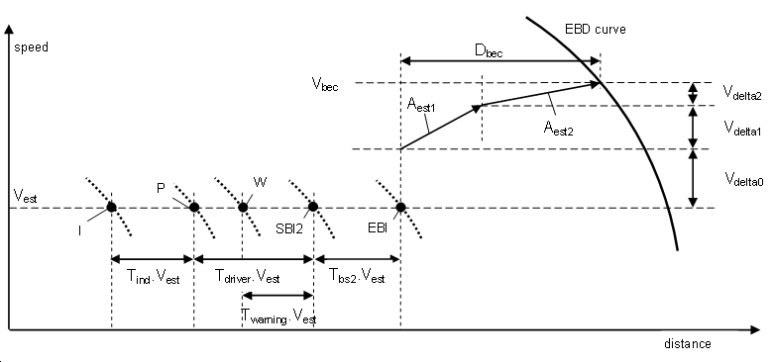

### SBI Curve

The issue is to define the SBI curve (curve of Service Brake Intervention) which permits to stop the train at the beginning of area and at the end of area, starting from an initial speed so-called “Vest” (V estimated) and following 2 assumptions :

* Deceleration is a constant value
* Deceleration is variable due to gradients or other factors.

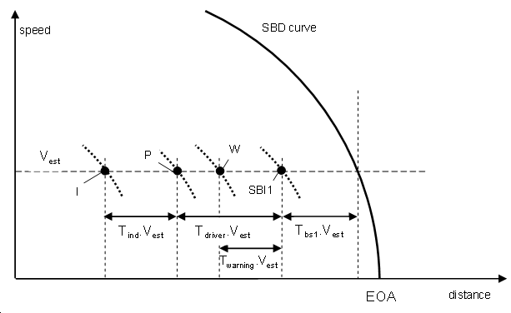

We take in consideration the limit of area as an EOA.

* SBD constant :
  + The distance to decrease speed from “Vest” to zero with constant deceleration Gsb is :

**Dsb = Vest ² / (2 * Gsb**) equation of “SBD curve”

* + Taking in consideration all response times, the distance will be :

**Dind = [ Vest ² / (2 * Gsb)] + [ Vest * (Tbs1 + Tdriver + Tind)]** equation of “Ind curve”

* SBD variable step by step :
  + The distance due to response times is unchanged :

**Dres = [ Vest * (Tbs1 + Tdriver + Tind)]** equation of “response time”

* + The distance due to 1st step defined by {V1 and Gsb1} is :

**Dind1 = [ V1 ² / (2 * G1)]**

* + The distance due to 2ndt step defined by {V2 and Gsb2} is :

**Dind2 = [ (V2 ² - V1 ²) / (2 * G2)]**

* + The distance due to step “n” defined by {Vn and Gsbn} is :

**Dend = [ (Vest ² - Vn ²) / (2 * Gn)]**

* + The final distance due to step “n =3” is the sum up :

**Dind = Dind1 + Dind2 + Dend**